Arm Keil MDK-Community Edition
Keil MDK is free to use for non-commercial projects under the Community Edition license. To activate a Community Edition license for use with μVision or Keil Studio for VS Code follow the instructions below.

Instructions to activate your copy of Keil MDK-Community edition in µVision
- Download and install µVision.
Download µVision Opens on keil.com
- Run μVision (no special rights required).
- Go to File > License Management... and select the User-Based License tab.
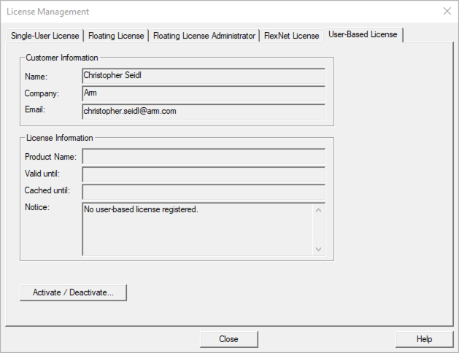
- Click Activate / Deactive... and the Arm License Management Utility will open.
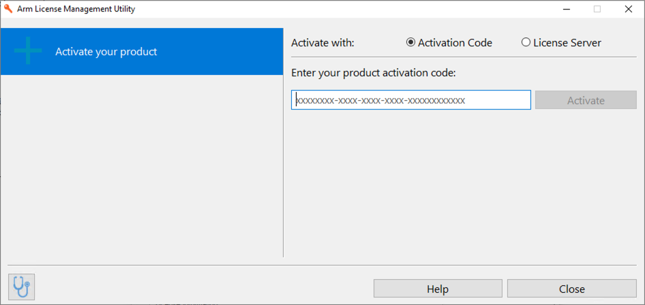
- Click on License Server... in the upper right corner.
- Enter https://mdk-preview.keil.arm.com as the license server address and click Query.
- Select Keil MDK Community... and press Activate.
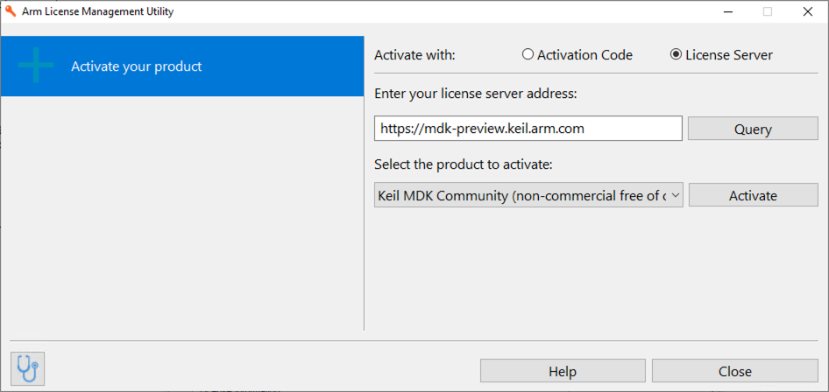
- The license will be activated.
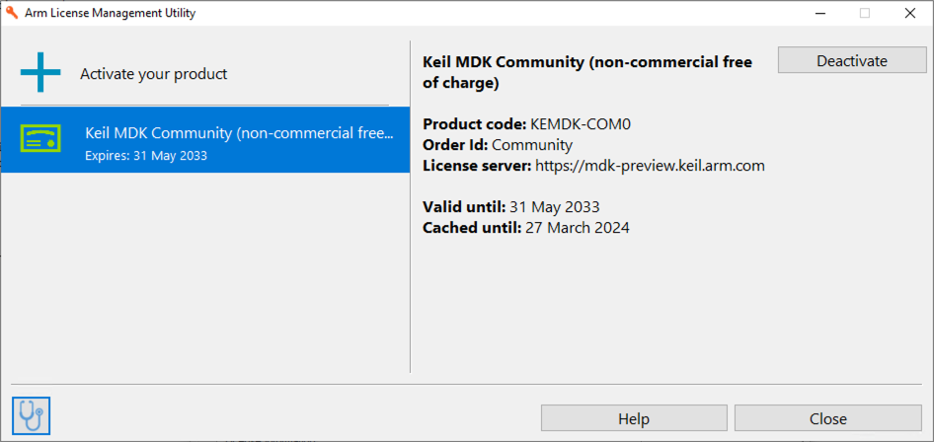
- Click Close twice.

